Speak Up Month 2021

Communications Toolkit

Speak Up Listen Up Follow Up

Background
October 2021 will be the fourth Speak Up Month.
Speak Up Month is an opportunity to raise awareness and the difference which Freedom to Speak Up is making.
This year the National Guardian’s Office is encouraging everyone to play their part to Speak Up, Listen Up and Follow Up.
We are planning a national campaign to illustrate the part which we all play in fostering a culture where people can speak up and be confident they will be listened to and that action will follow for learning and improvement.
If you would like to be part of the national campaign, your contribution will be posted onto our website www.nationalguardian.org.uk and shared on our social media channels on Twitter and LinkedIn. Please get in touch if you would like to get involved
We will use the hashtags #SpeakUpListenUpFollowUp in addition to our usual hashtag #FTSU and for guardians #SpeakUpToMe

Core messages
We have drafted a generic text for articles/bulletins which you are free to adapt and use within your organisation and add in supportive messages from your senior leadership

Social Media
These sample tweets can also be adapted for other social media platforms like LinkedIn, Facebook or Instagram

Tweet 1
Welcome to Speak Up Month 2021.
Everyone has a part to play to #SpeakUpListenUpFollowUp
By working together, we can foster an open culture where people are listened to and learning and improvement is welcomed #FTSU

Tweet 2
Have you completed the #SpeakUpListenUpFollowUp e-learning yet?
Once you have, submit a #SpeakUpPledge here: https://www.e-lfh.org.uk/programmes/freedom-to-speak-up/
#FTSU

Tweet 3
We all have a voice that counts
Speaking up is a gift because it gives an opportunity for improvement.
Take the #SpeakUpListenUpFollowUp e-learning here and submit a #SpeakUpPledge
https://www.e-lfh.org.uk/programmes/freedom-to-speak-up/
#FTSU

Tweet 4
When someone speaks up, it is important we listen up.
Part 2 of the #SpeakUpListenUpFollowUp e-learning focuses on listening to concerns and understanding barriers to speaking up
https://www.e-lfh.org.uk/programmes/freedom-to-speak-up/
#FTSU

Tweet 5
When leadership #FollowUp this promotes a culture where everyone has a voice.
Look out for Follow Up, the final module of the #SpeakUpListenUpFollowUp e-learning package, out soon #FTSU
https://nationalguardian.org.uk/speaking-up/training-for-workers/

Hashtags: #SpeakUpListenUpFollowUp
#FTSU or if you are a guardian you can use #SpeakUpToMe
Feel free to tag @NatGuardianFTSU on your posts on Twitter or https://www.linkedin.com/company/national-guardian%27s-office on LinkedIn.

Imagery
You can download these and other resources from
https://nationalguardian.org.uk/additional-resources-for-ftsu-guardians/speak-up-month-resources-for-guardians/#

Twitter cards
We have twitter cards to complement your social media posts which you are welcome to use to promote your own blogs or content about Speak Up Month. Samples are below and can be downloaded from the resources page
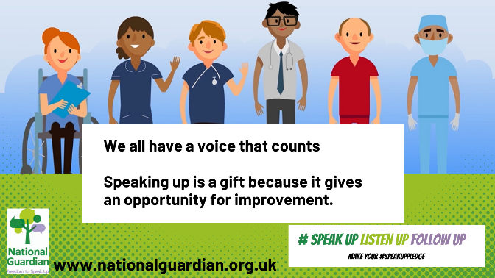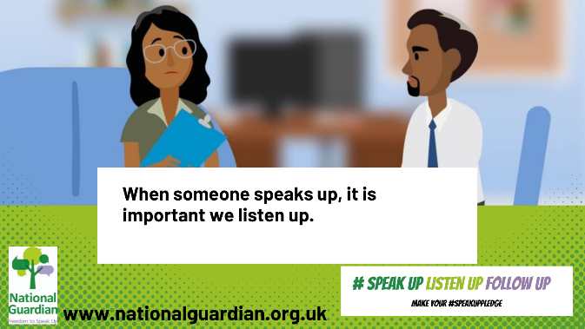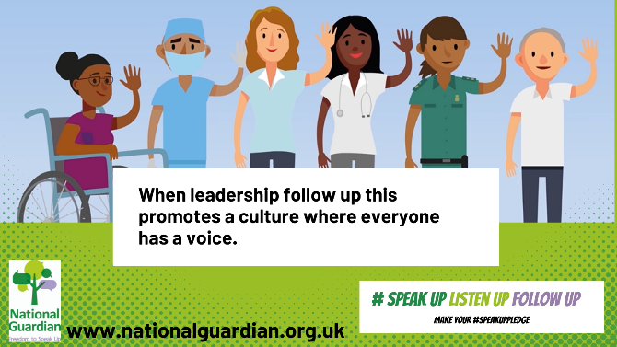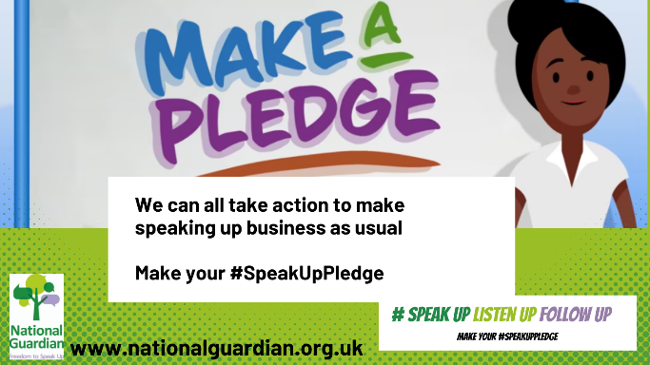

Email signature
An email footer can be downloaded from the website.

Other marketing collateral
Guardians can access other marketing collateral and download resources from the NGO website at https://nationalguardian.org.uk/additional-resources-for-ftsu-guardians/speak-up-month-resources-for-guardians/#
These include: poster, virtual background, word search and pledge cards

Videos
We will be sharing videos throughout the month, so please follow the NGO YouTube channel.
Make a Pledge https://youtu.be/Uiqllc1QcSw
These videos may also be helpful:
What is speaking up? https://youtu.be/_KCt6240CjA
An insight into speaking up https://youtu.be/BIFX8ZAWezY
Why Freedom to Speak Up matters https://youtu.be/CPhIxQOc0Rc
Being a Freedom to Speak Up Guardian https://youtu.be/B8z7jYf4GL0

National Guardian’s Office
Comms Team Contact details: comms@nationalguardianoffice.org.uk
- Website: www.nationalguardian.org.uk
- Twitter @NatGuardianFTSU
- LinkedIn https://www.linkedin.com/company/national-guardian's-office/
- YouTube https://www.youtube.com/channel/UC4_b44gnRLYElCmSioBievQ

